Hospital Management System

Group Members:

* Sebastian Silva Benites
* Syed Ikramuddin
* Hardipsih Matroja
* Mustafa Ali Taleb Al-Omari
* Louie Go
* Kamalkumar, Patel
* Neethu Dominic



# Part A: Requirements Analysis Document

## Section 1: Problem Statement

### 1.1.a. Problem and Need

Dealing with hospitals and doctors it’s no easy task, getting a date for your appointment, not forgetting when you made the appointment, receiving your prescription and forgetting where you put it. It may not seem so difficult but with the increasing speed of day-to-day life it gets more complicated every time. Also, the hospital may have some problems, confusing dates, not registering appointments or delaying the delivery of the patient's history.

Therefore, we will make a software where patients, doctors and hospital staff will have their account where they can manage appointments and patient’s history and prescription medicines. Patients can book appointments online whilst the doctor and hospital admins can see, manage or reschedule appointments. Patients can also consult the doctors using the video interface from anywhere. Moreover, patients can see prescriptions, doctor's advice and review their own medical history.

### 1.1.b. Capabilities and Benefits

(i) Capabilities

* Manage Doctors Appointments
* Display and Store Patient's History
* Display Doctors Available hours
* Display and Store Patients Prescriptions
* Manage Patient’s personal information
* Online consultation through video call

(ii) Benefits

* Minimize time on looking up records for a certain patient
* Remove the paper-based system completely
* Create a more systematic and organized way of keeping and storing patient’s records
* Create an easier way to make an appointment with a doctor.
* Patients will receive quicker way to check lab results

### 1.2. Stakeholders and their roles

* Hospital Management Employees
* Admin: full access to the system.
* Staff: interacts with the customers and users of the application.

- IT Management

- Receptionist

* Doctors: Manage appointments and add data to patient’s history
* Staff: Manage users
* Lab Technicians: Manage Lab Procedures appointments and send results
* Pharmacist: Gets prescriptions and manage the delivery of said prescription
* Patient: Uses the application to get appointments and review their medical history
  + In Patient
  + Outpatient

### 1.3. Subsystems of the application

* Login and Registration Subsystem
* Consultation Subsystem
* Pharmacy Subsystem
* Lab Management Subsystem
* Administration Subsystem

### 1.4. Intended User of the SRS documentation

* Developers
* UX Designers
* Admin Management
* IT Management

## Section 2: Context Flow Diagram

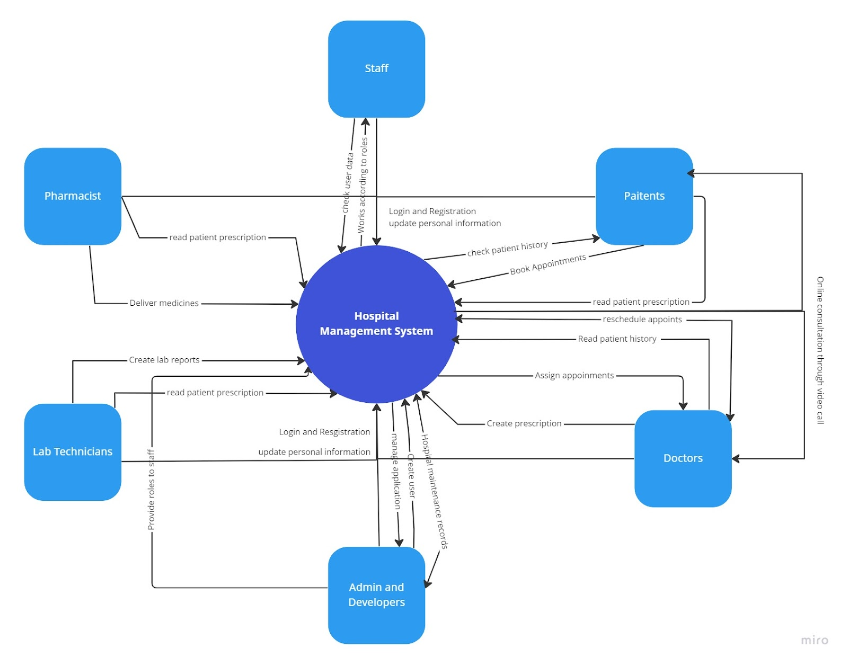

## Section 3: Requirements

### 3.1. Login and Registration Subsystem

#### 3.1.1. Goal Use Cases

|  |  |  |  |
| --- | --- | --- | --- |
| #FR | Goal Use case | Role | Description |
| FR001 | Login into Dashboard | All Roles | Login into the corresponding Dashboard |
| FR002 | Change Password | All Roles | Allow all roles to change their current password |
| FR003 | Register as Patient | Patient | Allow new patients to create their account |
| FR004 | Create hospital user | IT Department, Admin | Allow the IT and Admin personnel to create new hospital users |
| FR005 | Logout of account | All Roles | Allow the user to logout from the system |

#### 3.1.2. Use Case Diagram

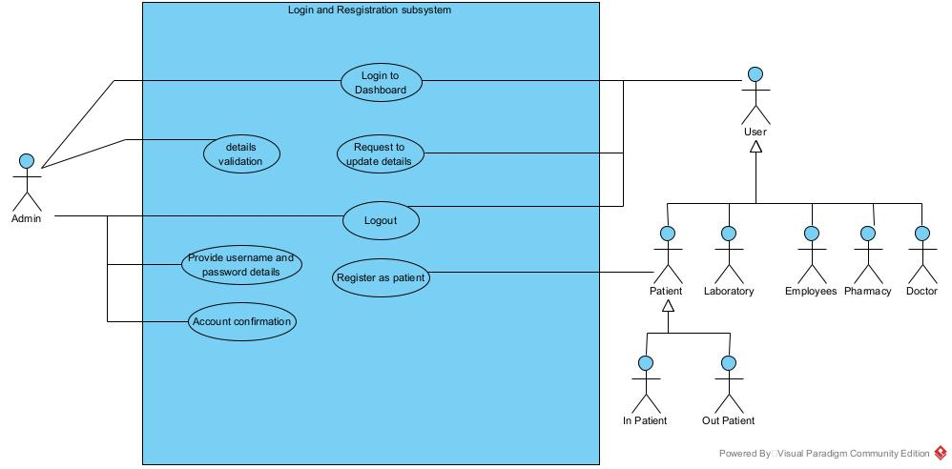

#### 3.1.3. User Stories

US-001. AS a Patient, I WANT to be able to create an account by inserting my name, last name, email, phone number and a password SO THAT I can use this account to access the application.

Acceptance Criteria:

* When I click the register link, then the application will redirect me to the registration page.
* When I have inserted all the required fields and pressed the register button, then I will receive a confirmation email and be redirected to the login page.

US-002. AS a User, I WANT to access the application by inputting my email and my password, SO THAT I can access the application.

Acceptance Criteria:

* When I click the login link, the application will redirect me to the login page.
* When I enter the email and password and click the login button, then I will enter to my home page

US-003. AS a System Admin, I WANT to create employee's users, SO THAT this newly created users can interact with the application.

Acceptance Criteria:

* When I click on the add link, The application will redirect me to the add user's page.
* After I enter all the required details and click on add button, the application will give me a confirmation.

US-004. AS a User, I WANT to logout of my account, SO THAT I can maintain my privacy if I leave the computer.

Acceptance Criteria:

* When I click on the logout link, the application will ask for confirmation.
* When I enter the confirmation, then I will be redirected to the login page.

US-005. AS a User, I WANT to change the password of my account, SO THAT I can maintain my data secure.

Acceptance Criteria:

* When I click on the change password link, the application will ask me the current password and new password.
* When I enter the details and click on the change button, the application will give me a confirmation.

### 3.2. Consultation Subsystem

#### 3.2.1. Goal Use Cases

|  |  |  |  |
| --- | --- | --- | --- |
| #FR | Goal Use case | Role | Description |
| FR006 | Check for Availability | OutPatient | Allow the user to search an available date for an appointment |
| FR007 | Online Consultation | OutPatient,Doctor | Allow the patient to consult the doctor using an online video interface. |
| FR008 | Confirm an Appointment | Doctor | Allow the user to confirm an appointment time and date. |
| FR009 | Reschedule an Appointment | OutPatient, Doctor, Admin | Allow the user to change or suggest a time and date change. |
| FR010 | Cancel Appointment | OutPatient, Doctor, Admin | Allow the user to cancel a scheduled appointment |
| FR011 | Send Prescription | Doctor | Allow the user to add a prescription to a patient |
| FR012 | Request Patient’s History | Doctor, OutPatient, InPatient | Allow the user to request a patient’s history |
| FR013 | Update Patient’s prescription | Doctor | Allow the user to update patient prescription |

#### 3.2.2. Use Case Diagram

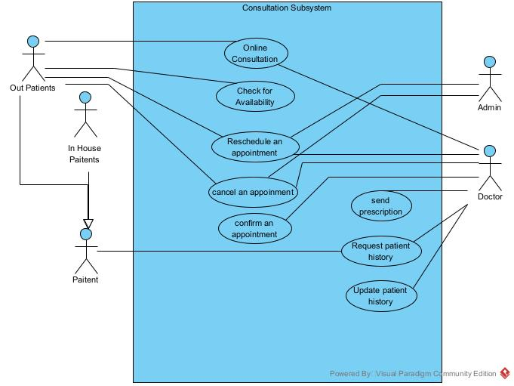

#### 3.2.3. User Stories

US-006. AS an Outpatient, I WANT to get a list of available physicians of a certain especially, SO THAT I can find a time and date that will suit me for an appointment.

Acceptance Criteria:

* When I enter to the consultation scheduling interface, I can select a specific speciality and a date, if both are correct the application will show me all the available doctors.
* When I entered a speciality and a date were there are not available doctors, the application will show me a prompt that tells me that there are no available doctors on that date.
* When I Select a doctor on the available doctors list, the application will show all the available hours of the doctor.
* When I select an available hour, the application will show a confirmation message, and if successful, it will do the reservation for the consultation.

US-007. AS an Outpatient, I WANT to request an appointment with a physician at a certain date and time, SO THAT I can get an appointment on that date.

Acceptance Criteria:

* When I click on the request link, the application will redirect me to that page.
* When I enter required details and click on the request button, the application will give a confirmation of request

US-008. AS a Doctor, I WANT to confirm an appointment, SO THAT the patient can be notified and come in the specified date and time.

Acceptance Criteria:

* When I click on the confirm button, the application will ask me for confirmation.
* When I click on the confirm button, the application will give me a confirmation

US-009. AS a Doctor or an Outpatient, I WANT to request a reschedule of an existing appointment, SO THAT I can move an established appointment in case of an emergency.

Acceptance Criteria:

* When I click on the reschedule link, the application will show me the list of available appointments.
* When I select and confirm my option, the application will give me a confirmation.

US-010. AS a Doctor or an Outpatient, I WANT to cancel an existing appointment, SO THAT date can be used by anyone else.

Acceptance Criteria:

* When I click on the cancel link, the application will ask for a confirmation.
* When I confirm it, the application will give me a confirmation.

US-011. AS a Doctor, I WANT to add a prescription to the history of the appointment, SO THAT the patient can use that prescription to get his or her medicines.

Acceptance Criteria:

* When I click on the add link, the application will redirect me to a page where I can add a prescription.
* When I add and click on the save button, the application will give me a confirmation.

US-012. AS a Doctor, I WANT to request a specific patient's history, SO THAT I can read and know what the patient has been taking, what other illnesses he or she has, or any other important information that may be present in the history.

Acceptance Criteria:

* When I Search for a patients name or Id, the basic information of the patient is displayed.
* When I click on the show patient history of a selected patient, it redirects me to a table display of said patient’s history.

US-013. AS a Doctor, I WANT to add information to the patient’s history, SO THAT anything prescribed or found in the appointment can be used or seen by other doctors and by the patient.

Acceptance Criteria:

* When I click on the add link, the application will redirect me to a page where I can add information.
* When I add and click on the save button, the application will give me a confirmation.

### 3.3. Pharmacy Subsystem

#### 3.3.1. Goal Use Cases

|  |  |  |  |
| --- | --- | --- | --- |
| #FR | Goal Use Case | Role | Description |
| FR014 | Request Patient’s prescription | Pharmacist, Patient | Allows the user to retrieve a specific patient’s prescription |
| FR015 | Verify Patient’s Prescription | Pharmacist | Allow the user to verify the information of a prescription |
| FR016 | Mark Prescription as Delivered | Pharmacist | Allow the user to add the approved check to a prescription |
| FR017 | Schedule Prescription for Deliver | Patient | Allow the user to schedule a delivery date for his or her prescription |
| FR018 | Track Prescription Delivery | Patient, Admin | Allow the user to get the status of a prescription delivery |

#### 3.3.2. Use Case Diagram

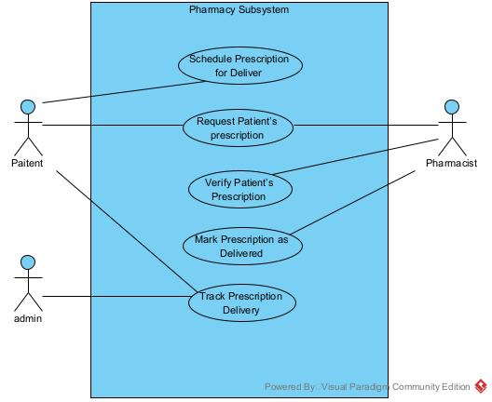

#### 3.3.3. User Stories

US-014. As a Pharmacist, I want to get a prescription from a patient that can easily get by the user and give them medicine accordingly.

Acceptance Criteria:

* When I click on a patient's application then it is attached to their application, and I can see prescription with that application.
* When I click the Done button, it will close the patient prescription and go into the history of the patient's application.

US-015. AS a Pharmacist, I WANT to verify the number, code, doctor or medicines that are in a prescription, SO THAT I can provide the correct medicines to the patient.

Acceptance Criteria:

* When I enter to the verification page, I can input the number code, doctor and medicines that are in the prescription, and the system will show me if it's all fine.

US-016. AS a Pharmacist, I WANT to change the status of a prescription to “delivered”, SO THAT the given prescription can’t be re-claimed.

Acceptance Criteria:

* When I enter the code of a prescription it shows me the verification page.
* When I click on the delivered button on the verification page, the state of that prescription is changed to delivered.

US-017. AS a Patient, I WANT to schedule my prescription for delivery, SO THAT I can receive my medicines on the scheduled date.

Acceptance Criteria:

* When I select a prescription that hasn’t been delivered yet, a scheduling interface appears.
* When I select a day, a confirmation prompt will appear to confirm the delivery date.

US-018. AS a Patient or an Admin, I WANT to check the delivery status of a specific prescription, SO THAT I can know if the delivery is going to take place.

Acceptance Criteria:

* When I enter a prescription Id or select a prescription, I will be redirected to the prescription information page.
* When I am in a prescription information page, I can see the prescription status.

### 3.4. Lab Management Subsystem

#### 3.4.1. Goal Use Cases

|  |  |  |  |
| --- | --- | --- | --- |
| #FR | Goal Use Case | Role | Description |
| FR19 | Upload or update reports | Lab Technician | Lab technician uploads or creates the created reports. |
| FR20 | Management of laboratories | Lab Admin | Admin can manage Laboratory users and patient’s lab data for future reference. |
| FR21 | Check Reports | Patients, Doctor | Patients can request for the collection of reports, Also the Lab techniciancan upload the test reports or can make changes if required. |
| FR22 | Collection of Sample  and create reports | Lab Technician | Lab technicians can collect the sample from patients and can create reports to verify with the doctors. |

#### 3.4.2. Use Case Diagram

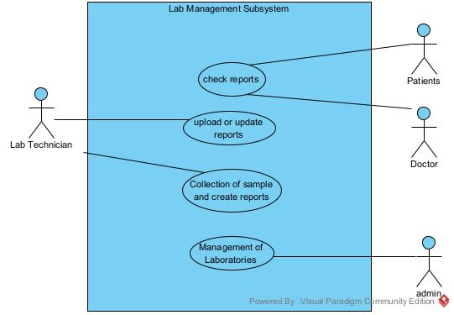

#### 3.4.3. User Stories

US-019. As a lab technician, I can create a patient's report and upload it to and send it to the lab admin after the test is completed.

Acceptance Criteria:

* After the lab test is completed, I can upload it into the lab management system and send it to the lab admin.
* I can request for lab inventory to the lab admin by clicking the request button.

US-20. As a patient or Doctors, I WANT to get reports, SO THAT I can check the values of each test.

Acceptance Criteria:

* When in hub I select the check lab reports, and I will be redirected to a lab reports list page.
* When a doctor clicks on search lab result by patient, I can input the name, id or email of the user to search for a specific lab result of a patient.

US-21. As a lab technician I can create a patients report after a patient sample drop in, SO THAT the data for the lab test can be updated.

* When I click the edit button, I can add a report or data to a test resquest.

### 3.5. Administration Subsystem

#### 3.5.1. Goal Use Cases

|  |  |  |  |
| --- | --- | --- | --- |
| #FR | Goal Use Case | Role | Description |
| FR23 | Request Users Data | Admin,Staff | Admin can get information of Patients, doctors and Staff |
| FR24 | Manage Full Application Errors | Admin,Staff | Admin can manage and deal with errors that may occur. |
| FR25 | Update Staff Data | Admin | Admin can update details of staff. |
| FR26 | Create Users | Admin | Create accounts for users like doctors, pharmacists, lab technicians, etc. |
| FR27 | Approve Leaves | Admin | Admin can approve leaves using application. |

#### 3.5.2. Use Case Diagram

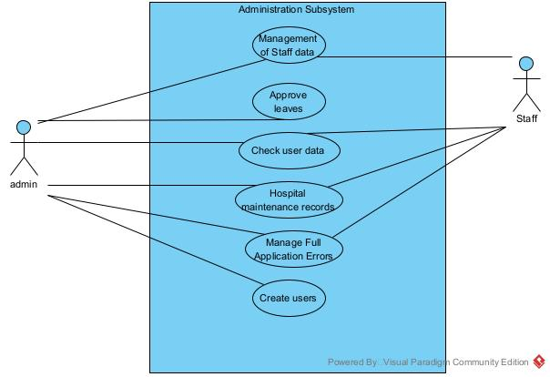

#### 3.5.3. User Stories

US-022. As Admin or Staff, I want to get the information of patients, doctors, or staff, so that I can verify them.

Acceptance Criteria:

* I can access the User search interface
* When I input a correct ID or username in the search bar, it will show me the corresponding user information page.
* When I input an incorrect ID or username, the interface will show me a message that says: “No valid user with that ID or username”.

US-022. AS Admin or Staff, I want to be able to see all the application errors and mark them as solve, or pending, so that everyone can keep track of the errors to be resolved.

Acceptance Criteria:

* When I enter the errors tickets page, the interface will show me a table of un-marked errors.
* When I press the marked as pending error or the marked as solved, the application will change the status of that error.

US-023. AS Admin, I WANT to update user’s details, SO THAT I can keep all the information up to date.

Acceptance Criteria:

* When I am in a valid user search information, and it is from a staff member, I can click the update button.
* When I click the update button, I will be redirected to an update information page.

US-024. AS Admin, I WANT to create new users, SO THAT we can have a valid user for a new staff member.

Acceptance Criteria:

* When I want to create a user, I select the create a new user button.
* When I am in the create user page, I can input the data of the specific user that has to be created.
* When I click in create, a prompt will appear telling me that the creation was a success, and I will be redirected to the home page.

US-025. AS Admin or staff, I WANT to approve leaves, SO THAT patients can leave when all the protocols are done.

Acceptance Criteria:

* When I search for a valid inpatient, I can click on the approve leave button and the state of the patient will change.

## Section 4: UML Domain Class Diagram

### 4.1. Classes

* User
* Doctor
* Patient
* Admin
* Patient History
* Prescription
* Pharmacist
* Lab
* Lab Technician
* Lab Procedure
* Appointment

### 4.2. Domain Class Diagram

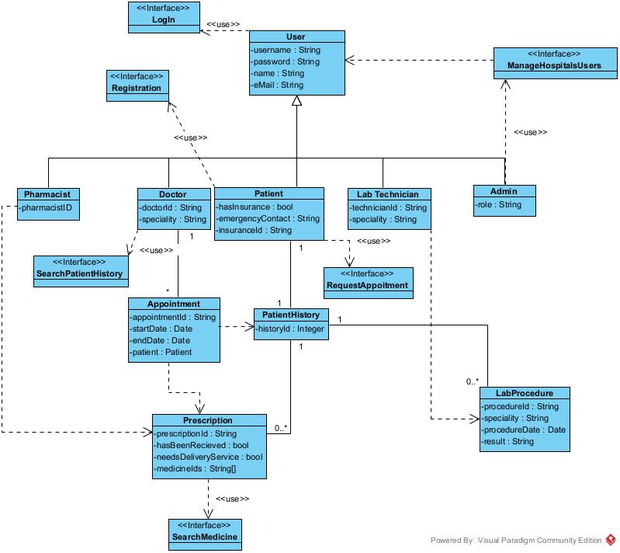

## Section 5: Entity Relationship Diagram

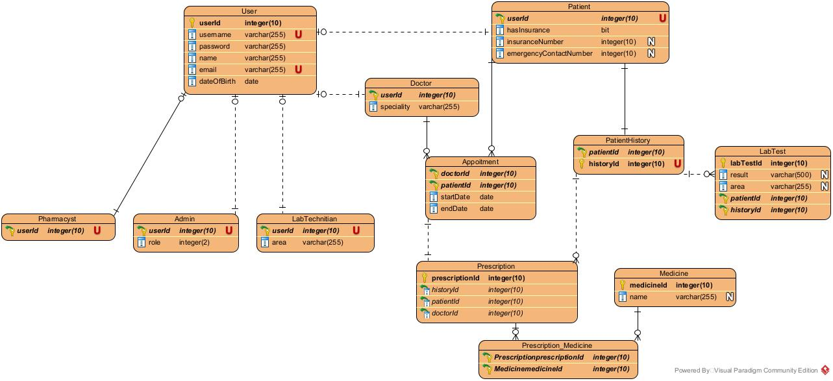

## Section 6: System Sequence Diagrams

6.1 Login system sequence diagram

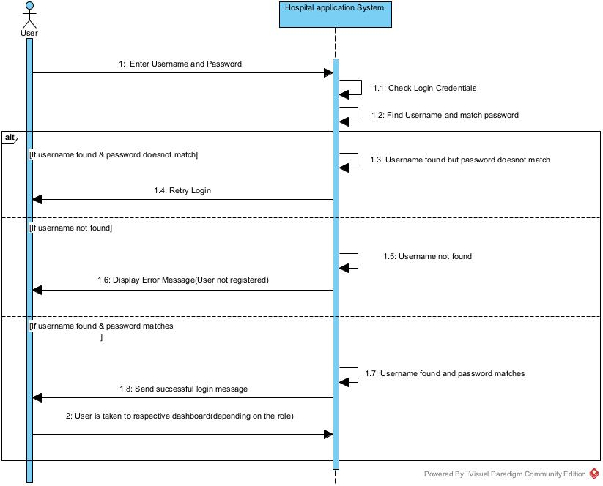

6.2 Reschedule an appointment system sequence diagram

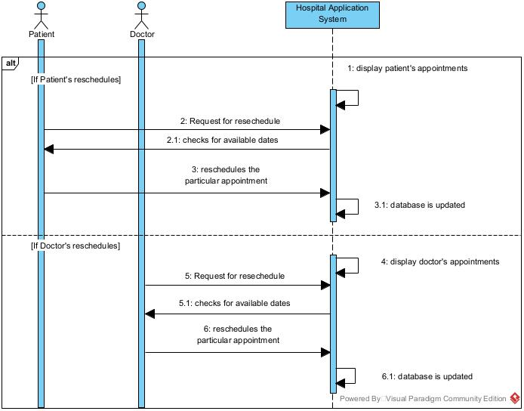

## Section 7: State Diagrams

### 7.1. Consultation – Schedule an Appointment

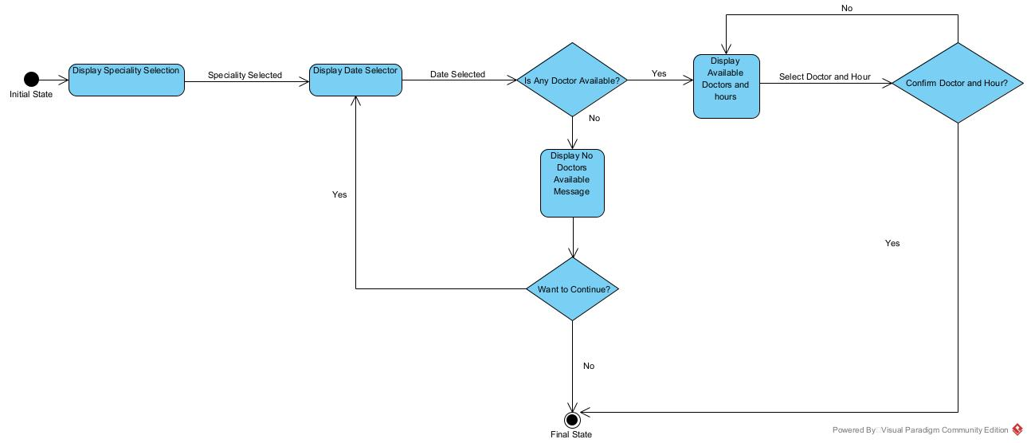

### 7.2. Registration

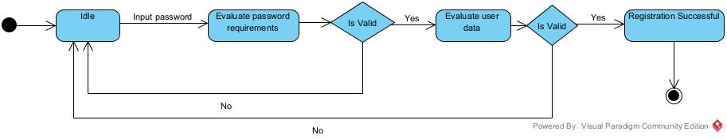

## Section 8: Technologies

This system will be implemented as a Web Application, that in the long run will be converted to a desktop application using Electron or Tauri.

### 8.1. Client Side:

* Angular
* Typescript
* NodeJS

### 8.2. Business Logic

* Java
* Spring Boot

### 8.3. Data Side

* MySQL
* Redis

## Section 9: Project Management – Gantt Diagram

